**Java**

**High Level Language**

**Code written in Java(Source Code)->Compiler ->Binary Form(Understandable to Computer)**

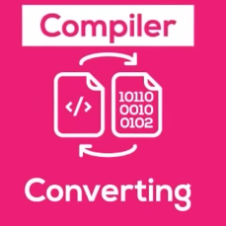

**Template to write Java Code**

class FirstClass{

    public static void main(String args[]){

    }

}

The JDK which we installed contains JRE (Java Runtime Environment ), the JRE contains JVM Java Virtual Machine

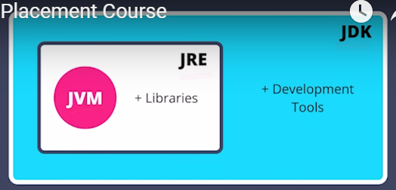

**Java Code is run through two steps**

**1)Compilation:**

The code we write in JAVA(Source code) goes to the compiler (Compiler is in Java Development Kit(JDK)).Compiler coverts the course code into byte code whose extension is .class

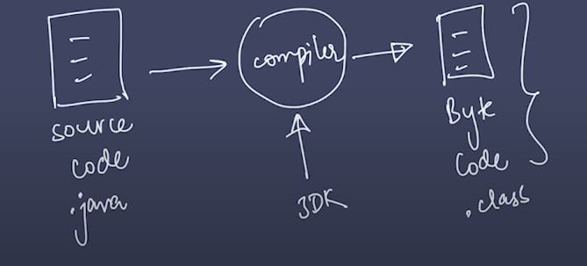

The byte code can be run on any operating system as long as OS has JRE(Java Runtime Environment)

**2)Execution**

The byte code is converted to native code(code understandable to machine) by Java Virtual Machine(JVM)

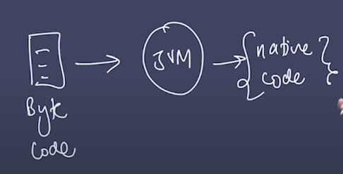

**Functions/Methods:**

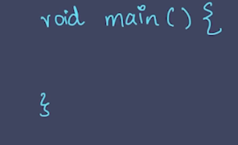

Main function executed first , in Java whatever is written first in the main function will be executed first

Name of the function is main

Return type of the function is void(returns nothing)

**Class**

We write these functions in class, class can contain many functions

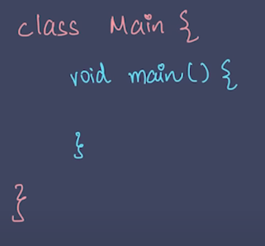

**Output in Java:**

**System is the name of class**

**System.out.print(name_of_variable);**



System.out.print("Hello World");

Anything written in “” will be printed as a string.

print

Print is a function in Java which we passed a string written in ""

print() method  does not insert a new line at the end of the output)

class FirstClass{

    public static void main(String args[]){

      System.out.print("Hello World Line 1");

      System.out.print("Hello World Line 2");

    }

}



**Using println**(println() method will add a new line at the end of each output) **and print**

class FirstClass{

    public static void main(String args[]){

      System.out.println("Hello World Line 1");

      System.out.print("Hello World Line 2");

         System.out.print("Hello World Line 3");

    }

}

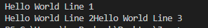

**Using “\n” next line**

class FirstClass{

public static void main(String args[]){

System.out.println("This is  Line 1\n This is  Line 2 \n This is  Line 3");

}}



Different **types** of variables

String surrounded by double quotes. A String variable contains a collection of characters surrounded by double quotes

int stores integers (whole numbers) without decimals

float stores floating point( decimals) numbers

char stores single characters such as 'a' or 'B' surrounded by single quotes

boolean stores values true or false

*type variableName = value;*

declare a variable(without assigning the value)

*type variableName;*

Assigning the value to the declared variable

*variableName = value;*

Use the f or F suffix to indicate that the literal value is of type float while declaring float variable. This is because by default, a floating-point literal without a suffix is treated as a double in Java.

**Assign a new value to an existing variable**

**will overwrite the previous value:**

boolean Boolean_variable=false;

      System.out.println("Boolean Variable value: "+Boolean_variable);

      Boolean_variable=true;

      System.out.println("Updated Boolean Variable: "+Boolean_variable);

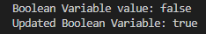

      boolean Boolean_variable=false;

      System.out.println(Boolean_variable);

      int interger_varaible=123;

      System.out.println(interger_varaible);

  float float_variable=3.21f;

      System.out.println("This is float variable"+float_variable);

      char char_varaible='A';

      System.out.println(char_varaible);

      String string_varaible="String Varaible";

      System.out.println(string_varaible);

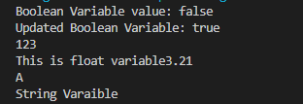

**Preventing Updating of Variable**

final type_of_varaible name_of_variable = existing value;

final int interger_varaible=123;

      System.out.println(interger_varaible);

      interger_varaible=123;



To combine both text and a variable, use the + character,

use the + character to add a variable(both variables as string or char type) to another variable:

  String first_string_variable="String 1  ";

     String second_string_variable="  String 2";

     String concate_string=first_string_variable+"and"+second_string_variable;

     System.out.println("The Concatenated String is "+concate_string);



**Char type**

 String first_string_variable="A";

     String second_string_variable="B";

     String concate_string=first_string_variable+" and "+second_string_variable;

     System.out.println("The Concatenated String is "+concate_string);



For numeric values, the + character works as a mathematical [operator](https://www.w3schools.com/java/java_operators.asp).

For int

int first_int_variable=123;

      int second_int_variable=23;

      int result;

      result=first_int_variable+second_int_variable;

      System.out.println("The Sum is "+result);



For float

float first_float_variable=12.3f;

      float second_float_variable=-12.3f;

      float float_result;

      float_result=first_float_variable+second_float_variable;

      System.out.println("The Float Sum is "+float_result);



Identifiers

unique names of Java **variables** are called identifiers

* Names can contain letters, digits, underscores, and dollar signs
* Names must begin with a letter
* Names should start with a lowercase letter and it cannot contain whitespace
* Names can also begin with $
* Names are case sensitive ("myVar" and "myvar" are different variables)
* Reserved words (like Java keywords, such as int or boolean) cannot be used as names

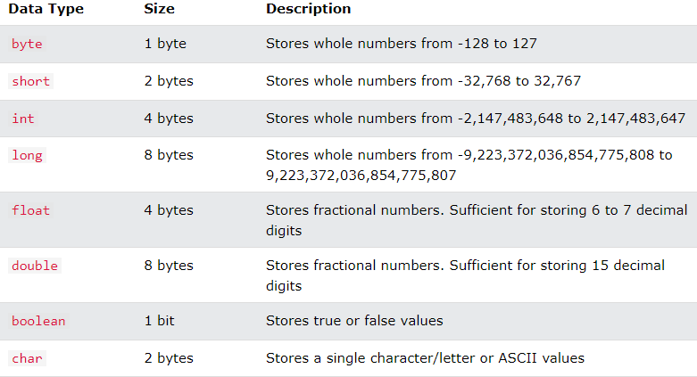

The byte data type can store whole numbers from -128 to 127. This can be used instead of int

The short data type can store whole numbers from -32768 to 32767.

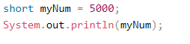

The int data type can store whole numbers from -2147483648 to 2147483647

The long data type can store whole numbers from -9223372036854775808 to 9223372036854775807.

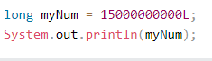

The float and double data types can store fractional numbers. Note that you should end the value with an "f" for floats and "d" for doubles.

The precision of a floating point value indicates how many digits the value can have after the decimal point. The precision of float is only six or seven decimal digits, while double variables have a precision of about 15 digits. Therefore it is safer to use double for most calculations.

A floating point number can also be a scientific number with an "e" to indicate the power of 10

float f1 = 35e3f;

double d1 = 12E4d;

System.out.println(f1);

System.out.println(d1);

The char data type is used to store a **single** character. The character must be surrounded by single quotes, like 'A' or 'c':

**ASCII VALUES**

Use ASCII values to display certain characters.

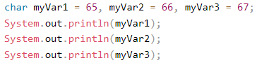

The String data type is used to store a sequence of characters (text). String values must be surrounded by double quotes

String greeting = "Hello World";

System.out.println(greeting);

## Non-Primitive Data Types

Non-primitive data types are called **reference types** because they refer to objects.

Primitive data types are created by the programmer and is not defined by Java.

Primitive data types can be used to call methods.

Primitive data types can have value null.

Primitive data types start with a lowercase letter.

# **Java Type Casting**

Assigning a value of one primitive data type to another type

Two types of casting

1) **Widening Casting**

Convert smaller primitive data type to a larger primitive data type size

Byte(8 bit) -> short(16 bit) -> char(16 bit)  -> int(32 bit) -> long(64 bit) -> float(32 bit) -> double(64 bit)

public class Main {

public static void main(String[] args) {

int myInt = 9; //32 bit

double myDouble = myInt; // Automatic casting: int to double

System.out.println(myInt); // Outputs 9

System.out.println(myDouble); // Outputs 9.0

}}

2)**Narrowing Casting** (manually)

Converting a larger primitive type to a smaller primitive size type  
double(64 bit) -> float(32 bit)  -> long(64 bit) -> int(32 bit)  -> char(16 bit)   -> short(16 bit)  -> byte(8 bit)

Narrowing casting must be done manually by placing the type in parentheses in front of the value.

public class Main {

public static void main(String[] args) {

double myDouble = 9.78d;

int myInt = (int) myDouble;//Manual casting: double(64 bit) to int(32 bit)

System.out.println(myDouble); // Outputs 9.78

System.out.println(myInt); // Outputs 9

}}

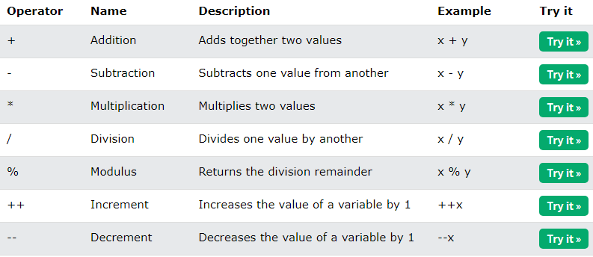

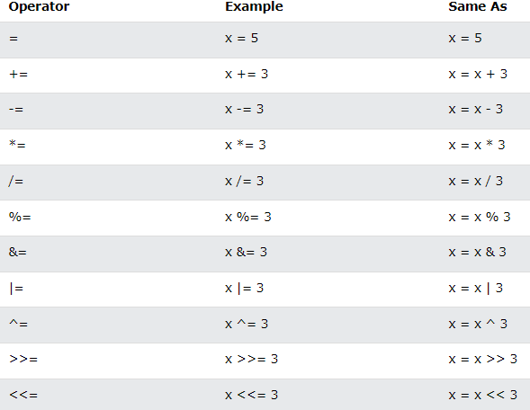

**Comparison Operator**

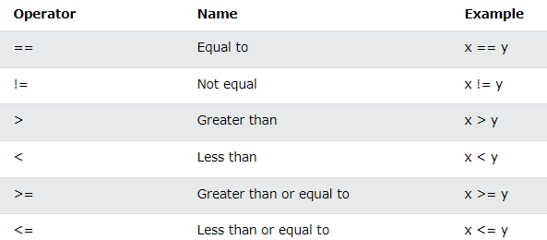

The return value of a comparison is either true or false

**Logical Operators**

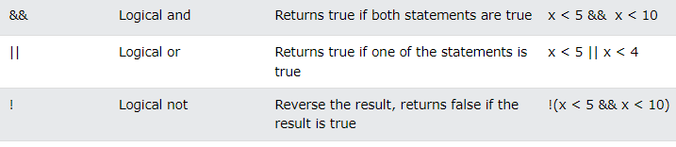

**String Object**

A String in Java is actually an object contain methods that can perform certain operations on strings.

Using length method of string object

String string_variable_object="I am string , also an object";

System.out.println("The length of the string is " +string_variable_object.length());



Using toUpperCase method

String string_variable_object="I am string , also an object";

System.out.println("The length of the string is " +string_variable_object.length()+

"\nThe string object in upper case is "+string_variable_object.toUpperCase()

);



## Finding a Character in a String

indexOf() method returns the **index** (the position) of the first occurrence of a specified text in a string (including whitespace):

String txt = "Please locate where 'locate' occurs!";

System.out.println(txt.indexOf("locate")); // Outputs 7

concat() method to concatenate two strings

String firstName = "John ";

String lastName = "Doe";

System.out.println(firstName.concat(lastName));

**Adding Strings**

String x = "10";

String y = "20";

String z = x + y; // z will be 1020 (a String)

**Adding Number and String**

String x = "10";

int y = 20;

String z = x + y; // z will be 1020 (a String)

## Strings - Special Characters

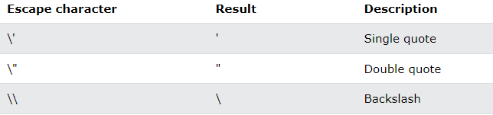

String txt = "We are the so-called \"Vikings\" from the north.";



String txt = "It\'s alright.";



String txt = "The character \\ is called backslash.";



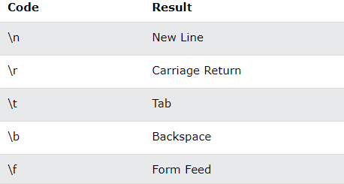

**Math Class**

The Java Math class has many methods that allows you to perform mathematical tasks on numbers.

Math.max

System.out.println(Math.max(5, -10));

Math.bs

System.out.println(Math.abs(-4.7));



Math.random() returns a random number between 0.0 (inclusive), and 1.0 (exclusive):

System.out.println(Math.random());

0.5454213934978203

random number between 0 and 100

int randomNum = (int)(Math.random() * 101); // 0 to 100

## if Statement

if a condition is true then block of Java code is executed

if (condition) {

// block of code to be executed if the condition is true

}

## The else Statement

Else block of code is executed if the condition is false.

if (condition) {

// block of code to be executed if the condition is true

} else {

// block of code to be executed if the condition is false

}

## else if Statement

Use the else if statement to specify a new condition if the first condition is false.

if (condition1) {

// block of code to be executed if condition1 is true

} else if (condition2) {

// block of code to be executed if the condition1 is false and condition2 is true

} else {

// block of code to be executed if the condition1 is false and condition2 is false}

**Ternary Operator**

variable *= (*condition*) ?* expressionTrue *:*  expressionFalse*;*

If the condition is true, then expressionTruewill be stored in the variable.

If the condition is false, then expressionFalse will be stored in the variable.

## Java Switch Statements

switch(*expression*) {

case x:

*// code block*

break;

case y:

*// code block*

break;

default:

*// code block*

}

* The switch expression is evaluated once.
* The value of the expression is compared with the values of each case
* If there is a match, the associated block of code is executed
* The break and default keywords are optional,
* x, y are the values of the case
* When Java reaches a break keyword it will stop the execution of more code and case testing inside the block.
* A break can save a lot of execution time because it "ignores" the execution of all the rest of the code in the switch block.
* The default keyword specifies some code to run if there is no case match.

**While Loop**

while (*condition*) {

*// code block to be executed*

}

code in the loop will run, over and over again, as long as a condition is true.

Do not forget to increase the variable used in the condition, otherwise the loop will never end!

## The Do/While Loop

 This loop will execute the code block once, before checking if the condition is true, then it will repeat the loop as long as the condition is true.

do {

*// code block to be executed*

}

while (condition);

int i = 0;

do {

System.out.println(i);//0 1 2 3 4

i++;

}

while (i < 5);

}

## Java Arrays

To declare an array in Java, define the variable type with **square brackets**:

String[] cars;

Type_of_array [ ] name_of_array;

To insert values to it, you can place the values in a comma-separated list, inside curly braces

String[] cars = {"Volvo", "BMW", "Ford", "Mazda"};

## Access the Elements of an Array

Access the Elements of an Array

String[] cars = {"Volvo", "BMW", "Ford", "Mazda"};

System.out.println(cars[0]);

**Change Array Element**

cars[0] = "Opel";

String[] cars = {"Volvo", "BMW", "Ford", "Mazda"};

cars[0] = "Opel";

System.out.println(cars[0]);

// Now outputs Opel instead of Volvo

**Array Length**

String[] cars = {"Volvo", "BMW", "Ford", "Mazda"};

System.out.println(cars.length);

// Outputs 4

## Loop Through an Array

Loop through the array elements with the for loop, and use the length property to specify how many times the loop should run.

String[] cars = {"Volvo", "BMW", "Ford", "Mazda"};

for (int i = 0; i < cars.length; i++) {

System.out.println(cars[i]);

}

## Loop Through an Array with ForEach

for (type variable : arrayname)

{...}

String[] cars = {"Volvo", "BMW", "Ford", "Mazda"};

for (String i : cars) {

System.out.println(i);}

## Multidimensional Arrays

A multidimensional array is an array of arrays.

To create a two-dimensional array, add each array within its own set of **curly braces**

int[][] myNumbers = { {1, 2, 3, 4}, {5, 6, 7} };

**myNumbers** is now an array with two arrays as its elements.

{1, 2, 3, 4} is the first row.

{5, 6, 7} is the second row.

## Access Elements

## To access the elements of the **myNumbers** array, specify two indexes: one for the array, and one for the element inside that array

int[][] myNumbers = { {1, 2, 3, 4}, {5, 6, 7} };

System.out.println(myNumbers[1][2]); // Outputs 7

Array indexes start with 0: [0] is the first element. [1] is the second element, etc.

## Change Element Values

Change the value of an element

int[][] myNumbers = { {1, 2, 3, 4}, {5, 6, 7} };

myNumbers[1][2] = 9;

System.out.println(myNumbers[1][2]); // Outputs 9 instead of 7

## Loop Through a Multi-Dimensional Array

Point to the two indexes to Loop through multi-dimensional array.

int[][] myNumbers = { {1, 2, 3, 4}, {5, 6, 7} };

for (int i = 0; i < myNumbers.length; ++i) {

for(int j = 0; j < myNumbers[i].length; ++j) {

System.out.println(myNumbers[i][j]);

}  
 }

myNumbers.length=2 so i=0,1

myNumbers[0].length=4, j=0,1,2,3 i=0

myNumbers[1].length=3, j=0,1,2 i=1

# **Java Methods**

A **method** is a block of code which only runs when it is called.

Pass data, known as parameters, into a method.

## Create a Method

Declared a method within a class

Define a method by name of the method, followed by parentheses **()**

 static return_type name_of_the_method()

{

}

static means that the method belongs to the Main class and not an object of the Main class

**Example**

public class Main {

static void myMethod() {

// code to be executed

}

}

The void keyword indicates that the method should not return a value

If you want the method to return a value, use a primitive data type (such as int, char, etc.) instead of void, and use the return keyword inside the method:

## Call a Method

To call a method in Java, write the method's name followed by two parentheses **()** and a semicolon**;**

Inside main, call the myMethod() method

public class Main {

static void myMethod() {

System.out.println("I just got executed!");

}

public static void main(String[] args) {

myMethod();

}

}

# **Method Parameters**

Information can be passed to methods as parameter.

We can pass Parameters to the methods upon defining them and Parameters act as variables inside the method

(type_of_parameter name_of_parameter)

public class Main {

static void myMethod(String fname) {

System.out.println(fname + " Refsnes");

}

We pass arguments to the myMethod when we call them

public static void main(String[] args) {

myMethod("Liam");

myMethod("Jenny");

myMethod("Anja");

}

}

**Storing the value returned by Method**

public class Main {

static int myMethod(int x, int y) {

return x + y;

}

public static void main(String[] args) {

int z = myMethod(5, 3);

System.out.println(z);

}

}

**A Method with If...Else**

public class Main {

// Create a checkAge() method with an integer variable called **age**

static void checkAge(int age) {

// If age is less than 18, print "access denied"

if (age < 18) {

System.out.println("Access denied - You are not old enough!");

// If age is greater than, or equal to, 18, print "access granted"

} else {

System.out.println("Access granted - You are old enough!");

}

}

public static void main(String[] args) {

checkAge(20); // Call the checkAge method and pass along an age of 20

}

}

// Outputs "Access granted - You are old enough!"

# **Java Method Overloading**

Multiple methods having the same name with different data types of parameters.

int myMethod(int x)

float myMethod(float x)

double myMethod(double x, double y)

**Example**

public class Main

{

static int plusMethod(int x, int y) {

return x + y;

}

static double plusMethod(double x, double y) {

return x + y;

}

public static void main(String[] args) {

int myNum1 = plusMethod(8, 5);

double myNum2 = plusMethod(4.3, 6.26);

System.out.println("int: " + myNum1);

System.out.println("double: " + myNum2);

}

}

## Method Scope

Variables declared directly inside a method are available anywhere in the method following the line of code in which they were declared

public class Main {

public static void main(String[] args) {

// Code here CANNOT use x

int x = 100;

// Code here can use x

System.out.println(x);

}

}

public class Main {

public static void main(String[] args)

{

// Code here CANNOT use x

{

// This is a block

// Code here CANNOT use x

int x = 100;

// Code here CAN use x

System.out.println(x);

} // The block ends here

// Code here CANNOT use x

}

}

## Recursion

public class Main {

public static void main(String[] args) {

int result = sum(10);

System.out.println(result);

}

public static int sum(int k) {

if (k > 0) {

//K=10

return k + sum(k - 1);

10+9+8+7+6+5+4+3+2+1

} else {

return 0;

}

}

}

10 + sum(9)  
10 + ( 9 + sum(8) )  
10 + ( 9 + ( 8 + sum(7) ) )  
...  
10 + 9 + 8 + 7 + 6 + 5 + 4 + 3 + 2 + 1 + sum(0)  
10 + 9 + 8 + 7 + 6 + 5 + 4 + 3 + 2 + 1 + 0

public class Main {

public static void main(String[] args) {

int result = sum(5, 10);

System.out.println(result);

}

public static int sum(int start, int end) {

if (end > start)

{

return end + sum(start, end - 1);

} else {

return end;

}

}

}

10+sum(10, 9)

+

9+sum(10, 8)

+

8+sum(10, 7)

+

7+sum(10, 6)

+

6+sum(10, 5)

+

5=45

## Classes and Objects

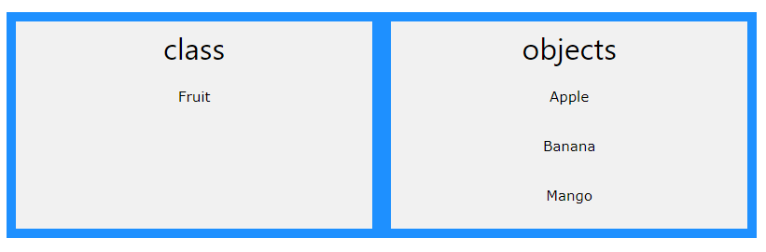

 class is a template for objects, and an object is an instance of a class.

**Blueprint or Template:**

A class defines the structure and behavior that objects created from the class will have. It is a blueprint because it outlines the attributes (data members) and behaviors (methods) that the objects will possess.

The class specifies what data the object will have (attributes) and what actions it can perform (methods).

Class defines the structure and behavior of objects in programming.

When the individual objects are created, they inherit all the variables and methods from the class. Top of Form

## Create a Class

To create a class, use the keyword class

class name should always start with an uppercase first letter, and that the name of the java file should match the class name.

public class Main {

int x = 5;

}

## Keyword class tells Java that we are creating a new class

## Member variables , data the object needs to store, exist through out the class. Declared outside any methods but inside declaration of class

## 

## Methods associated with Class:

## Distance method

## 

## Constructor

## Gets called when object of type SimpleLocation gets created

## 

## Create an Object

## When we write

  new SimpleLocation(-1.4,4.5);

## An Object gets created and constructor

public SimpleLocation(double lat,double lon) {

        this.lattitude=lat;

        this.longitude=lon;

    }

## gets called , we store this object inside variable

SimpleLocation object_one=new SimpleLocation(-1.4,4.5);

SimpleLocation object_two=new SimpleLocation(-11.4,34.43);

## of type name of class whose object is created

An object is created from a class

We can use these objects

 object_one.distanceMethod(object_two);

to call methods

 public double distanceMethod(SimpleLocation argument){

        // this refers to the calling object

        //this=object_one

        // and argument=object_two

         return(this.lattitude, this.longitude,argument.lattitude,argument.longitude);

        }

inside the class

To create an object of Main, specify the class name, followed by the object name, and use the keyword new:

name_of_Class name_of_Object=new name_of_Class();

public class Main {

int x = 5;

public static void main(String[] args) {

Main **myObj** = new Main();

System.out.println(myObj.x);

}

}

## Multiple Objects of One Class

Main **myObj1** = new Main(); // Object 1

Main **myObj2** = new Main(); // Object 2

create an object of a class and access it in another class

one class has all the attributes and methods, while the other class holds the main() method (code to be executed)

Create two files in the same directory/folder:

Main.java

Second.java

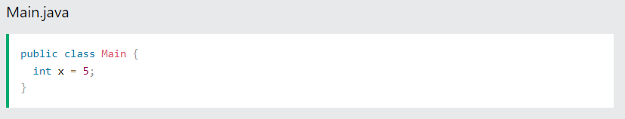

Creating an object of a Main class in Second calss and access it in Second class.

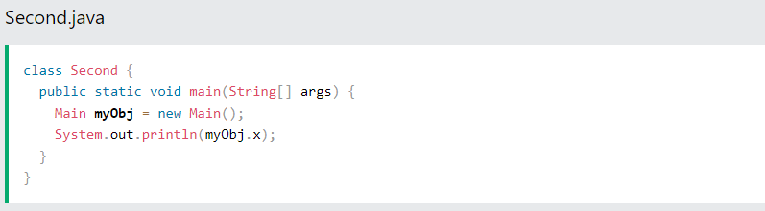

## Class Attributes/Fields

## variables within a class

public class Main {

int x = 5;

int y = 3;

}

## Accessing Attributes

Accessing attributes by creating an object of the class, and by using the dot syntax (.)

public class Main {

int x = 5;

public static void main(String[] args) {

Main myObj = new Main();

System.out.println(myObj.x);

}

}

## Modify/Override Attributes

public class Main {

int x;

public static void main(String[] args) {

Main myObj = new Main();

myObj.x = 40;

System.out.println(myObj.x);

}

}

## Multiple Objects

Create multiple objects of one class, change the attribute values in one object, without affecting the attribute values in the other

public class Main {

int x = 5;

public static void main(String[] args) {

Main myObj1 = new Main(); // Object 1

Main myObj2 = new Main(); // Object 2

myObj2.x = 25;

System.out.println(myObj1.x); // Outputs 5

System.out.println(myObj2.x); // Outputs 25

}

}

## Class Methods

 Methods are declared within a class.

**static**: Indicates that the method belongs to the class

static return_type_ name_of_method(parameters)

{

return result;//Optional Depending on the return type

}

public class Main {

static void myMethod() {

System.out.println("Hello World!");

}

}

To call a method, write the method's name followed by two parentheses **()** and a semicolon**;**

public class Main {

static void myMethod() {

System.out.println("Hello World!");

}

public static void main(String[] args) {

myMethod();

}

}

## we created a static method can be accessed without creating an object of the class.

Method created by public, which can only be accessed by objects

public class Main {

// Static method

static void myStaticMethod() {

System.out.println("Static methods can be called without creating objects");

}

// Public method

public void myPublicMethod() {

System.out.println("Public methods must be called by creating objects");

}

// Main method

public static void main(String[] args) {

myStaticMethod(); // Call the static method

// myPublicMethod(); This would compile an error

Main myObj = new Main(); // Create an object of Main

myObj.myPublicMethod(); // Call the public method on the object

}

}

## Access Methods With an Object

 Create a custom Main class with the class keyword.

// Create a Main class

public class Main {

// Create a fullThrottle() method

public void fullThrottle() {

System.out.println("The car is going as fast as it can!");

}

// Create a speed() method and add a parameter

public void speed(int maxSpeed) {

System.out.println("Max speed is: " + maxSpeed);

}

// Inside main, call the methods on the myCar object

public static void main(String[] args) {

// Create an Object of main class

Main myCar = new Main(); // Create a myCar object

myCar.fullThrottle(); // Call the fullThrottle() method

myCar.speed(200); // Call the speed() method

}

}

Creating an object of a class and accessing it in another class.

#### **Main.java**

public class Main {

public void fullThrottle() {

System.out.println("The car is going as fast as it can!");

}

public void speed(int maxSpeed) {

System.out.println("Max speed is: " + maxSpeed);

}

}

#### **Second.java**

class Second {

public static void main(String[] args) {

Main myCar = new Main(); // Create a myCar object

myCar.fullThrottle(); // Call the fullThrottle() method

myCar.speed(200); // Call the speed() method

}

}

## Java Constructors

A special method that is called when an object of a class is created.

Constructor name must match the class name.

All classes have constructors by default: if you do not create a class constructor yourself, Java creates one for you.

Constructor has no return type.

ClassName(parameter1Type parameter1,parameter2Type parameter2,)

{ }

**Example:**

public class Main {

int x; // Create a class attribute

// Create a **class constructor** for the Main class

public Main() {

x = 5; // Set the initial value for the class attribute x

}

public static void main(String[] args) {

Main myObj = new Main(); // Create an object of class Main (This will **call the constructor**)

System.out.println(myObj.x); // Print the value of x

}

}

Constructors can also take parameters, which is used to initialize attributes

The following example adds an int y parameter to the constructor. Inside the constructor we set x to y (x=y). When we call the constructor, we pass a parameter to the constructor (5), which will set the value of x to 5.

public class Main {

int x;

public Main(int y) {

x = y;

}

public static void main(String[] args) {

Main myObj = new Main(5);

System.out.println(myObj.x);

}

}

// Outputs 5

## Access Modifiers

private variables can only be accessed within the same class (an outside class has no access to it).

## Encapsulation

The meaning of **Encapsulation**  is to hide "sensitive" data from users.

* declare class variables/attributes as private
* provide public **get** to access private variables and **set** methods to update the value of a private variables.

get method returns the variable value.

set method sets the value.

public class Person {

private String name; // private = restricted access

// Getter

public String getName() {

return name;

}

// Setter

public void setName(String newName) {

this.name = newName;

}

}

JAVA API

<https://docs.oracle.com/javase/7/docs/api/>

JAVA Basic to Advance

<https://docs.oracle.com/javase/tutorial/>

<https://www.tutorialspoint.com/java/>

<https://www.guru99.com/java-tutorial.html>

<http://www.learnjavaonline.org/>

For Unfolding Maps

<http://unfoldingmaps.org/tutorials/index.html>

Eclipse:

<http://help.eclipse.org/neon/index.jsp>

<https://www.tutorialspoint.com/eclipse/>

<http://www.vogella.com/tutorials/Eclipse/article.html>

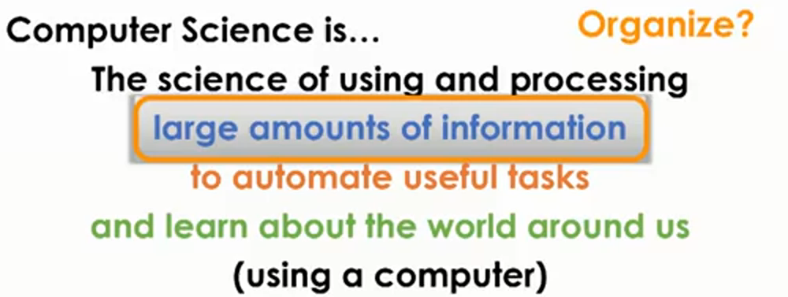



Class is a custom data type that we get to define to match the problem that we are trying to solve

Class is kindda like a factory

Class can produce pieces of data with the template that we get to define



Object comes out of the class , it is a piece of data

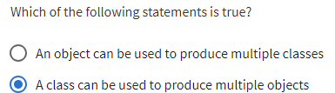

**Building class for Location**

To represent location we need two pieces of data.

1)Latitude

2)Longitude

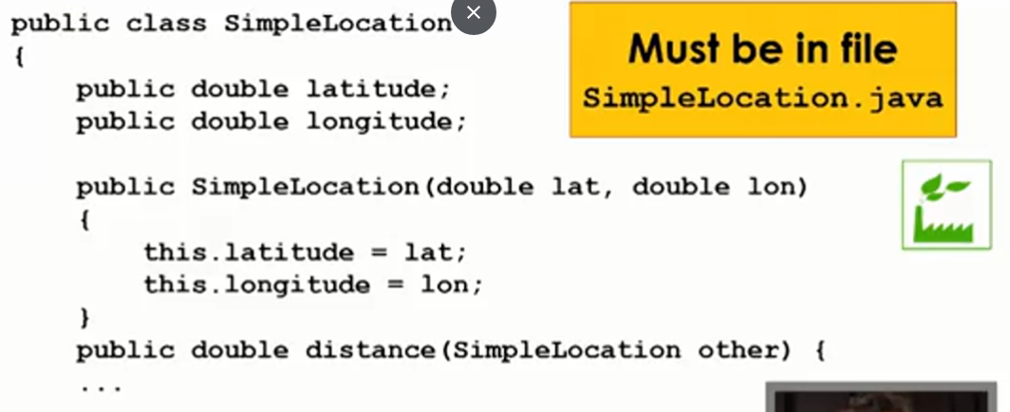

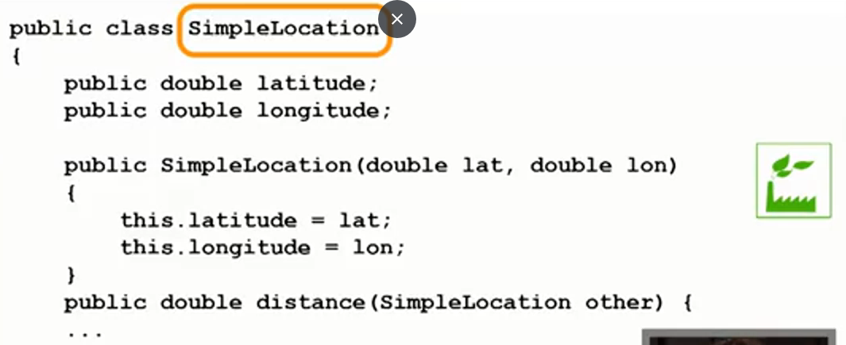

SimpleLocation is the name of class

Class key word tells Java that we are creating a new class

**Data Associate with SimpleLocation class**

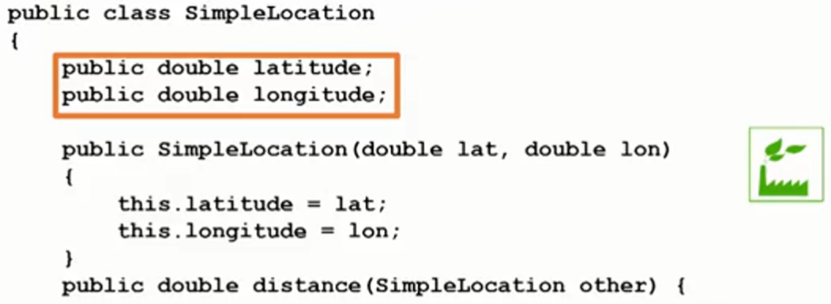

These variables exist throughout the class.



**Methods Associate with Class:**

Methods means things a class can do.

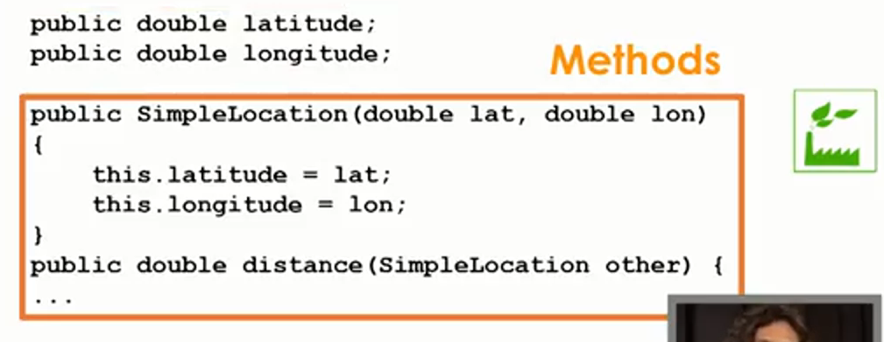

Distance Method:Takes SimpleLocation and other(Other Simple Location out in the world ) as a parameter and returns the distance between one simple Location(Other Simple Location out in the world ) and SimpleLocation that’s passed in

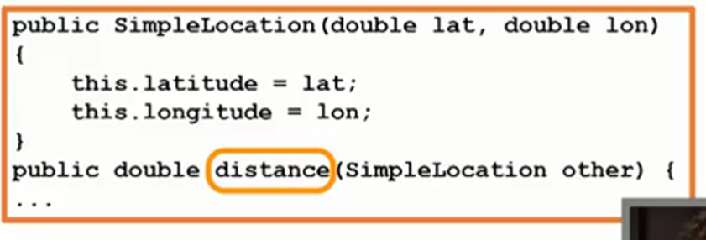

There is only one argument in distance method which is other , the type of the other argument is SimpleLocation.

**Constructor:**

Special Method that gets called when my objects get created

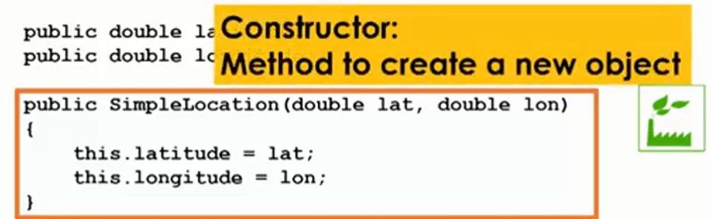

Constructor has no return type, name of the constructor is the name of the class

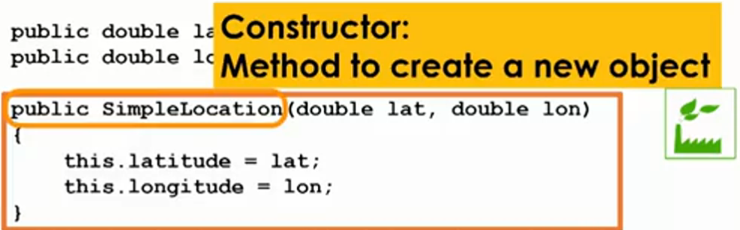

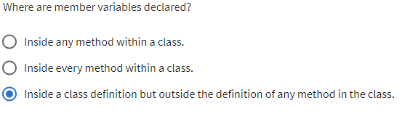



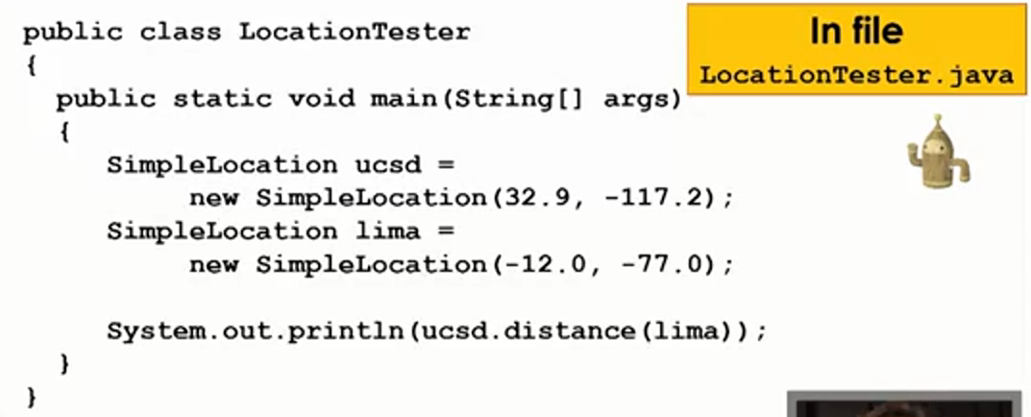

Main method inside LocationTester class

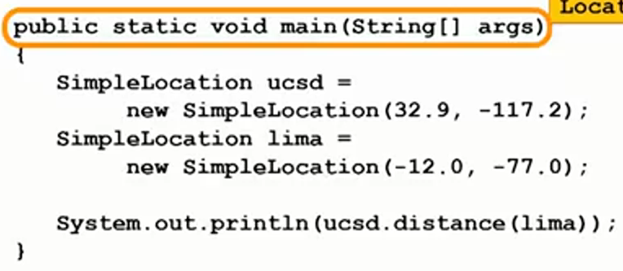

Creating New Objects

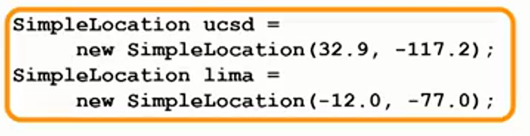

Name_of_class name_of_object=new Name_of_class()

Creating Object with class name SimpleLocation will call the

Constructor

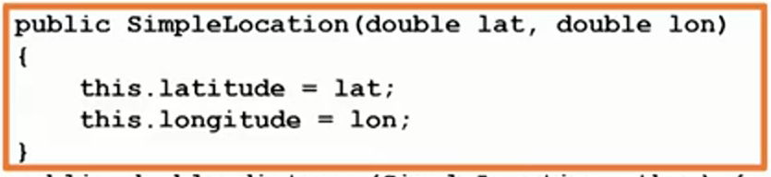

Hence arguments must be passed to the newly created objects , these argument associated with particular object will go to the constructor and arguments associated with particular object will be accessed by this key word.

Calling distance method by ucsd object and passing lima object to distance method

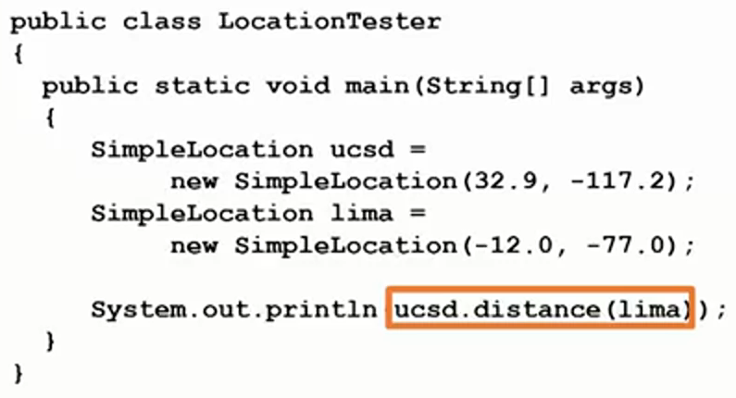

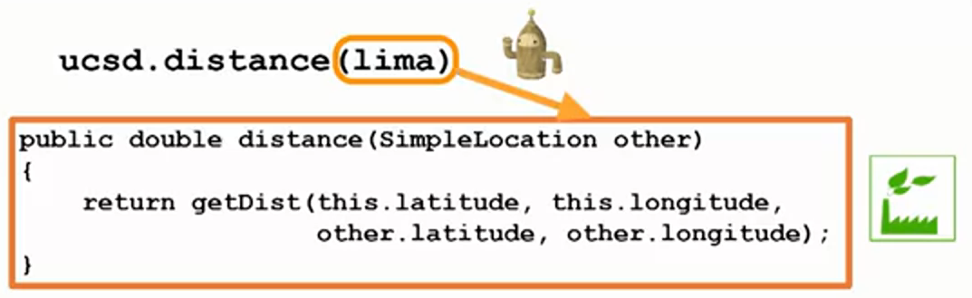

Other is the lima object and

this keyword refers to the calling ucsd object which is calling the distance method

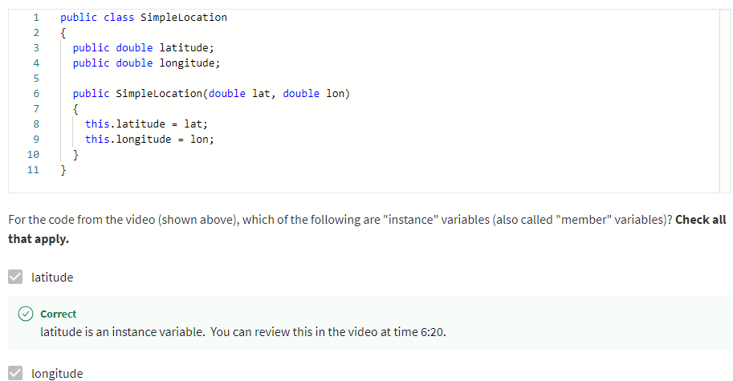

**Overloading Constructors**

**Create a new constructor , that takes no parameters(default constructor).**

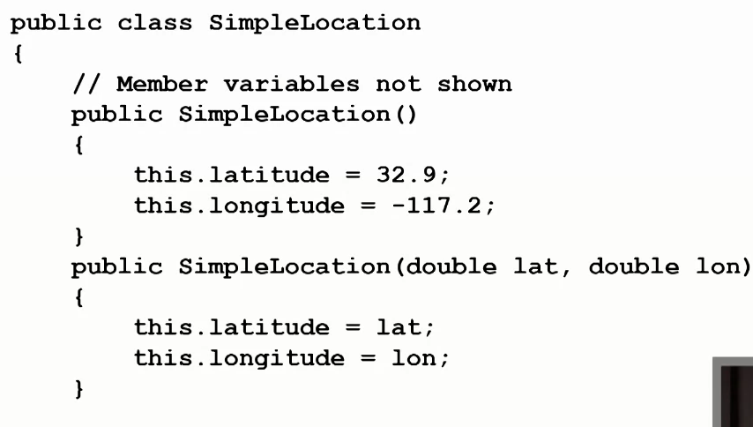

These are the default values

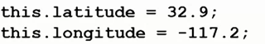

There is still another constructor which takes parameters(Parameters Constructor)

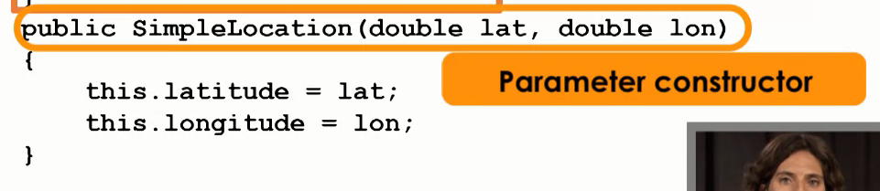



These two constructors can exist in the same class

There are two different constructors which take different numbers (0,2) and type of parameters(double).

**Overloading Methods** 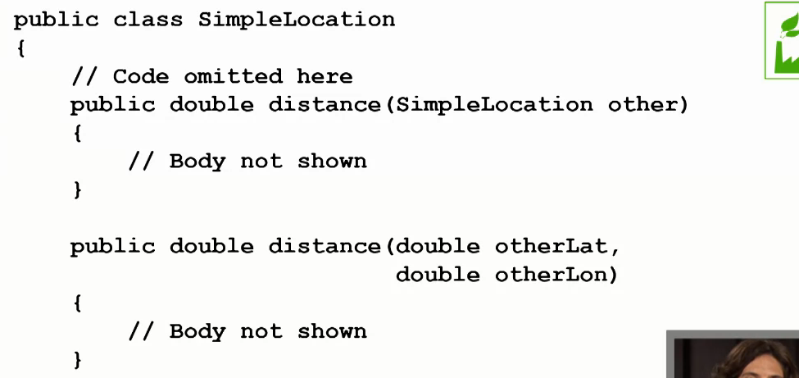



Distance method with one parameter

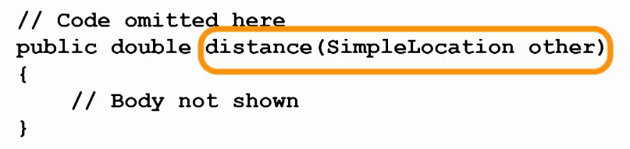

Distance method with more than one parameters.

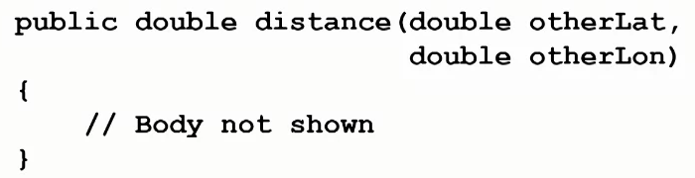

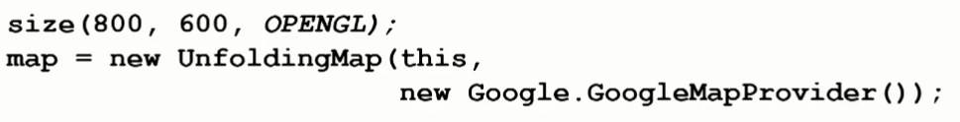

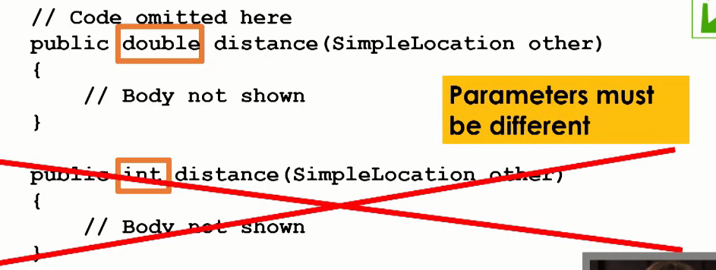

We are not allowed to have a method with the same parameter list and different return type, there parameter list must be different.

Methods with different return types and different parameter list are allowed.

Method with same name, same parameter list and different return type is not allowed.

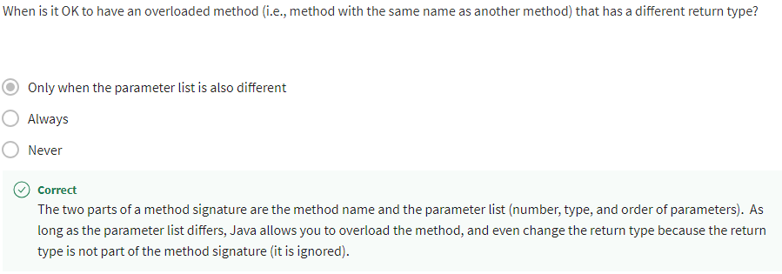

**Public Member Variables**



Anyone can access these member variables from any class at all.

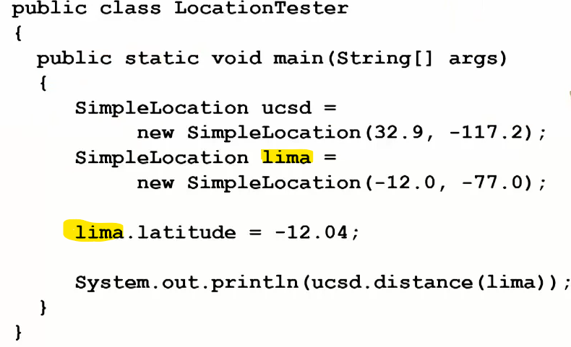

**Public Methods**

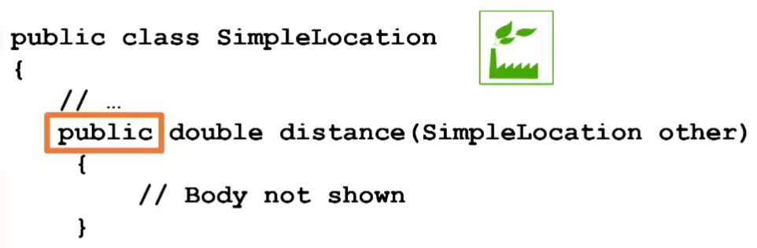

We can access this method in other class.

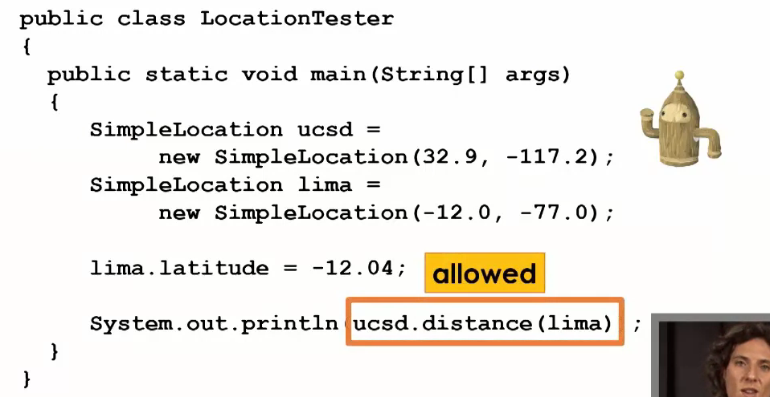



**Private Member Variables**

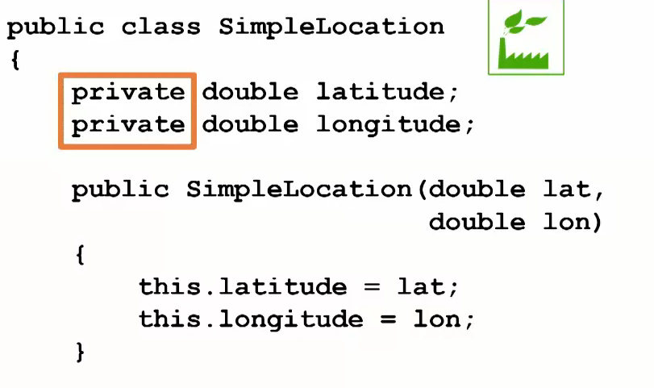

If private member variables are declared private then they can be accessed or set inside the class where they are declared private.

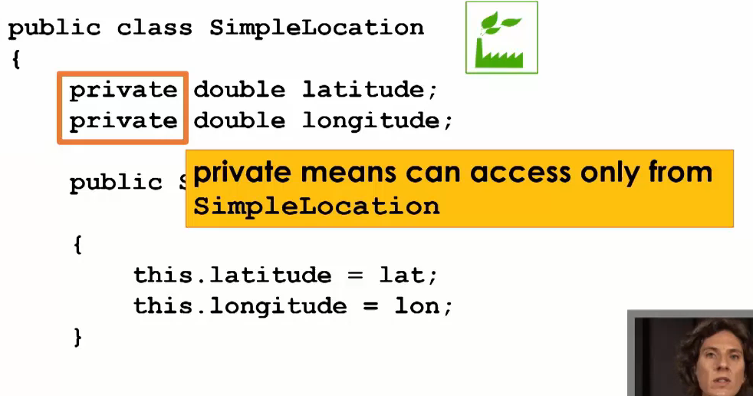



Same close the method

But using constructor the private member variables can be accessed or reset.

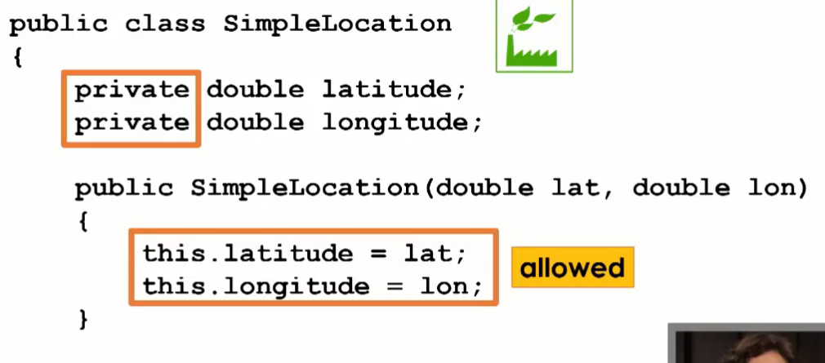



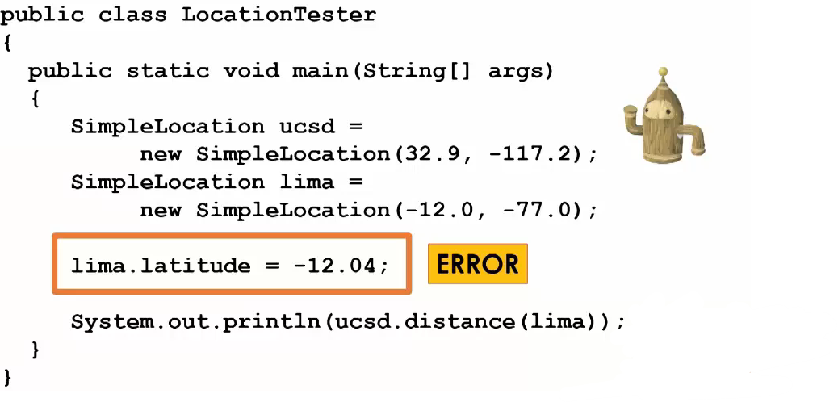

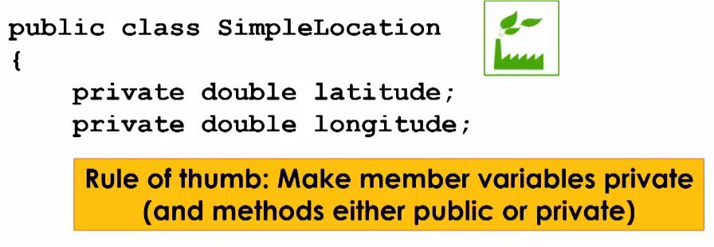

**Getters and Setters**

**Getter:**

Take the value of private member variable and expose/return it outside the class, variable itself is private but we can access the variable outside the calls by calling getter.

This key word points to the object that will call getLatitude() method

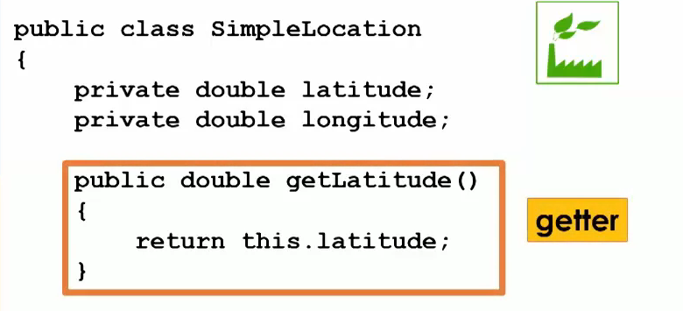

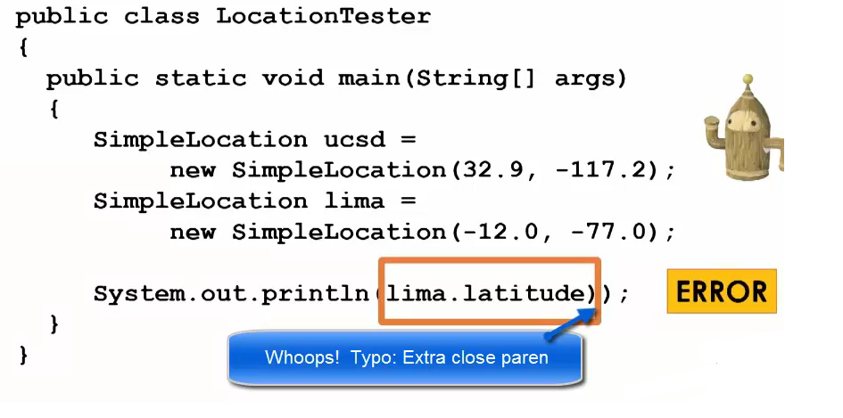

An object trying to access the private member variable of SimpleLocation class.

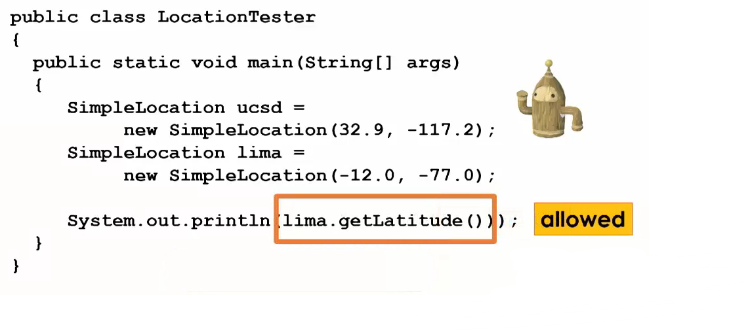

getLatitude will return the value of the object which (object)is calling getLatitude() public method

**Setter**

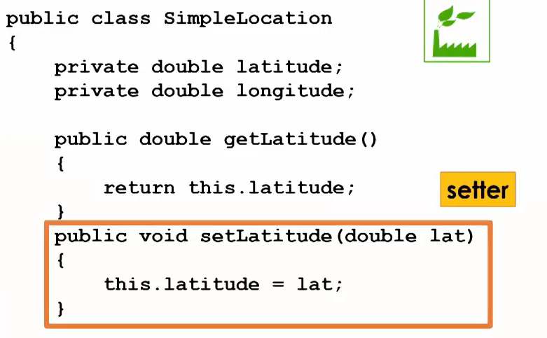

Setter takes in the value lat and changes the value of the private member variable to the value that was passed in by the user.

This key word points to the object which will call the setLatitude method.

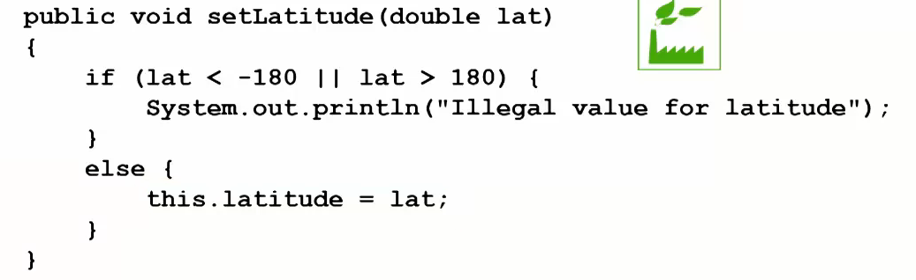

<https://www.coursera.org/specializations/statistics>

**Variable Scope:**

**6 Variables**

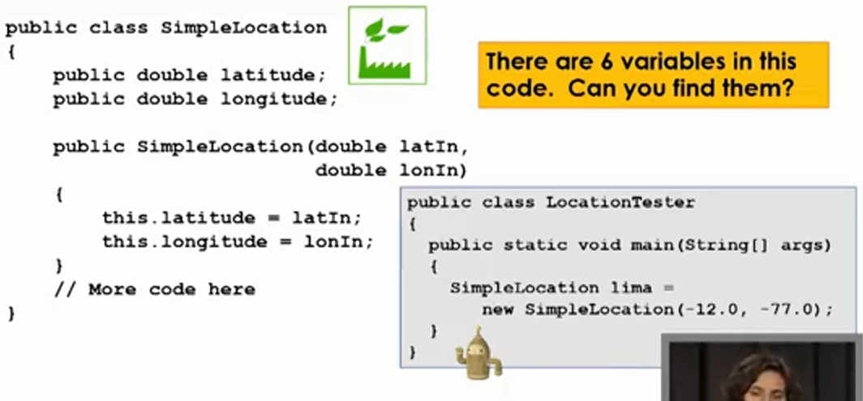



**Member Variables**

They are also variables.



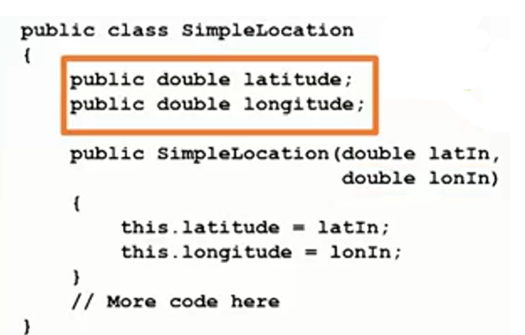



Declared outside any method in the class

Their scope is entire class.

Refer to these variables from any method inside the class.

They can be accessed from any method within the same class. This means that you can refer to and use these variables in any method that is defined inside the class.

**Parameters of Constructors:**



**Parameters are arguments passed into the method:**

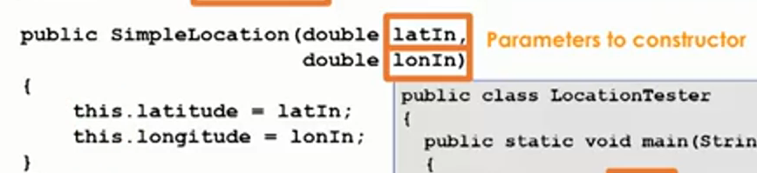



**Local Variables:**



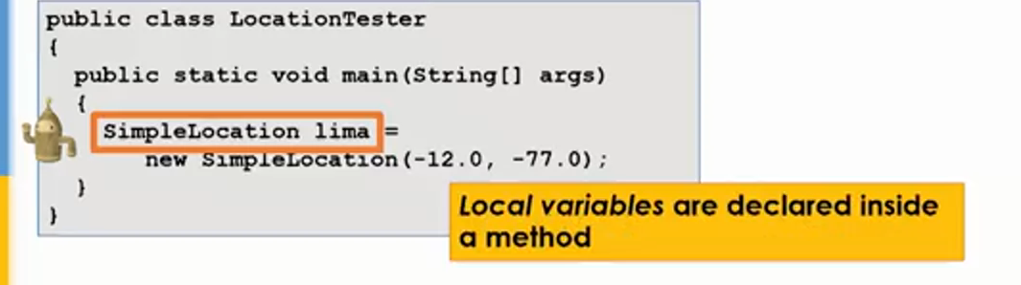

**Main is the method, lima is local variable:**

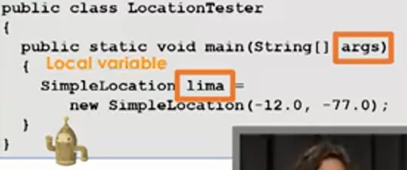



**Parameters to main method**

**args**

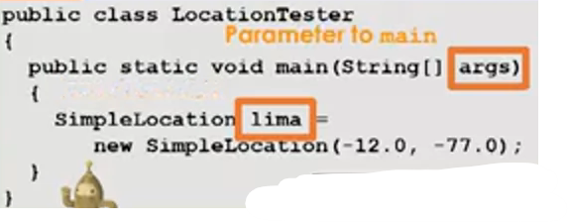

**Scope:**



**Understanding the notion of scope using Memory Model:**

**Local Variable Scope**

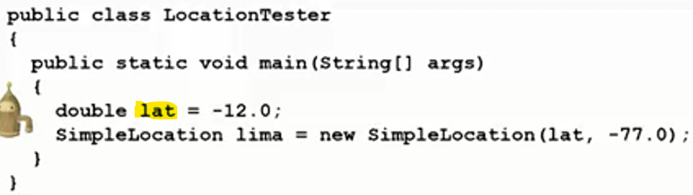



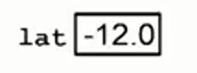

**Scope of lat is only main**

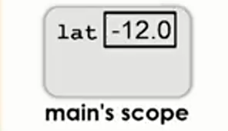

**So lima’s scope is only inside main**

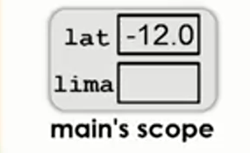

**Now since lima is an Object type variable , it will store location(address) of the object**



**or reference to the object**



**The object of SimpleLocation class get created in Heap**

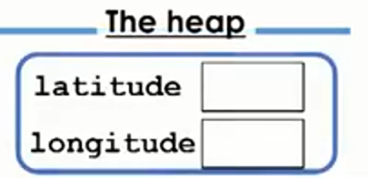

**The member variables of Object (latitude, longitude) get placed inside Object, hence their scope is only the object created in heap.**

**Parameters Variable Scope:**

When constructor

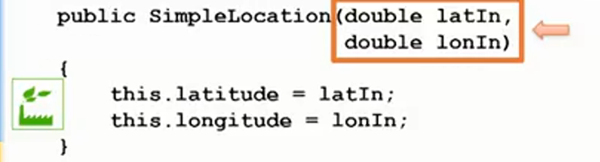

gets called, parameters variables latIn and lonIn get instantiated, their scope is local to the constructor.

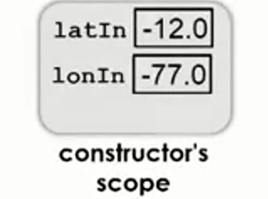

This key word’s scope is also the constructor

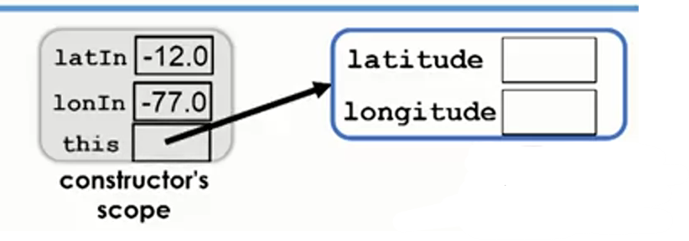



This refers to calling Object.

This stored the address, location of the object that we created in heap.

The value stored in this is the reference to the newly created object or location of the object.

**This inside method:**

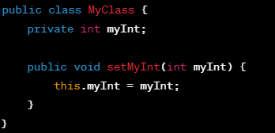

**This inside Constructor:**

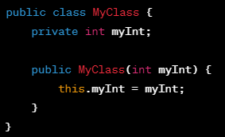

The value if latIn is copied and put into this.latitude inside the Object

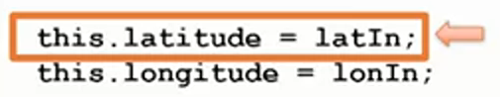



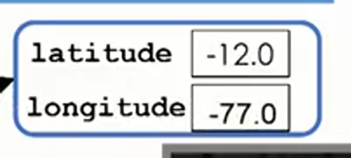



When the method ends it’s scope disappears.





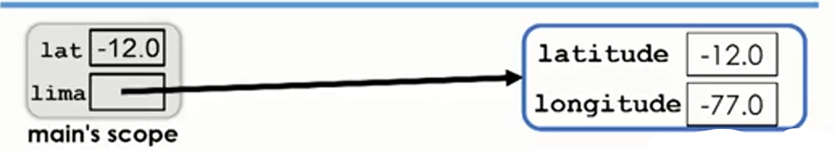



If we leave this key word

Java sees latitude variable , it will look for latitude inside scope of the method(constructor or any other method),

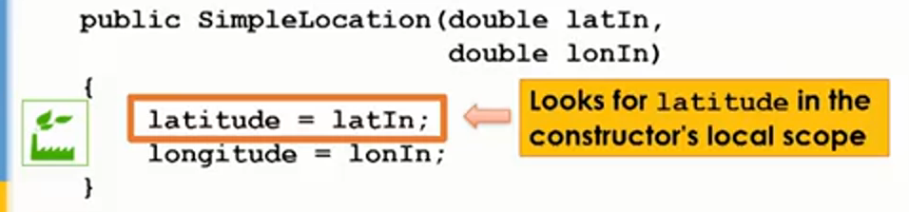

if latitude is not found, Java will look for the variable inside Object(calling Object)

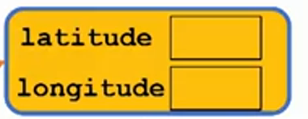

And variable gets changed

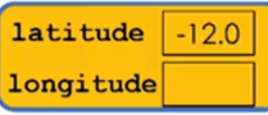

Problem

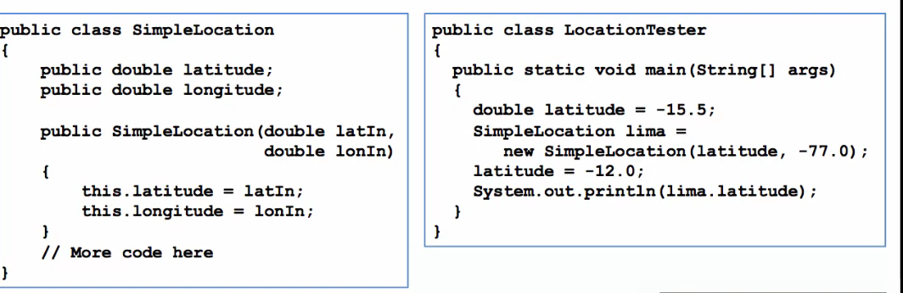

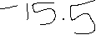



this.lat refers to the object in heap.

lima local variable contains the address or location or reference of newly created object created in heap.

It will get the value of the member variable latitude present in the lima object using dot.

The dot (**.**) is used to access members (fields or methods) of an object in Java.

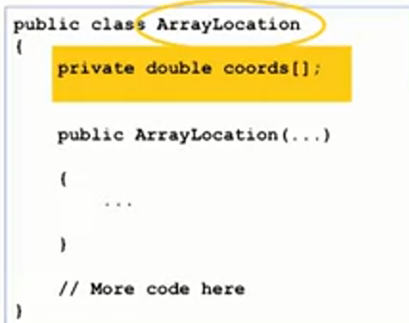

The name of array is coords and it is of double type

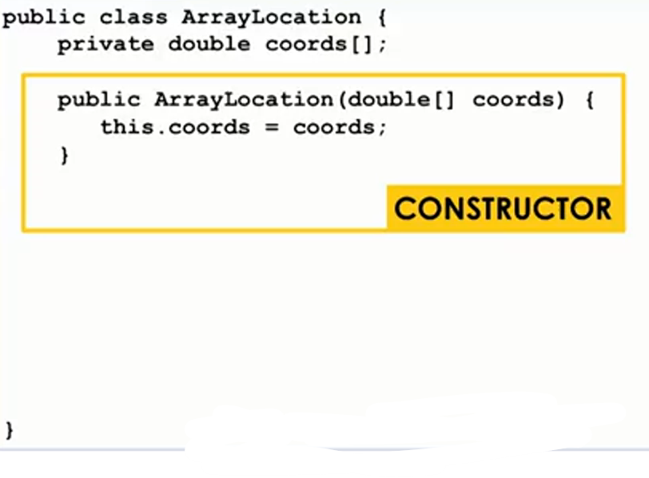



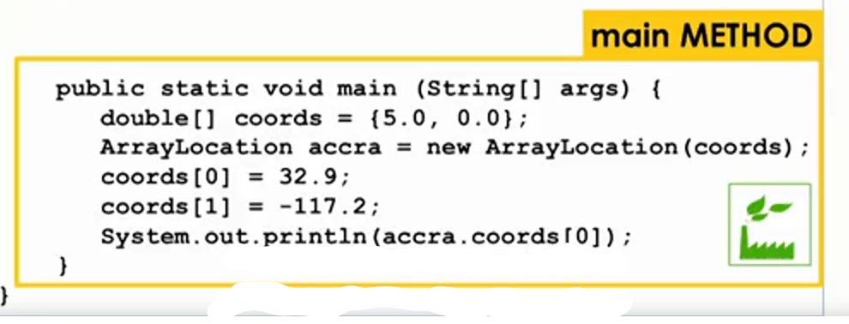



Defining a new array and initializing it to 5.0 and 0.0

double[] coords={5.0,0.0}

accra contains the reference or address or location of new array object created in heap

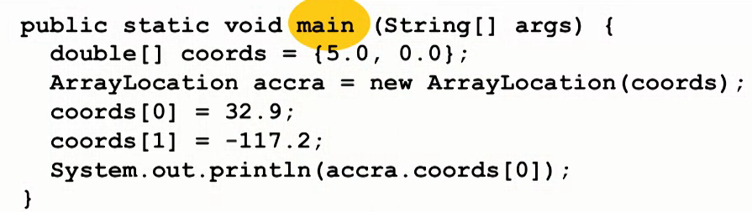

**Local Variable to main:**



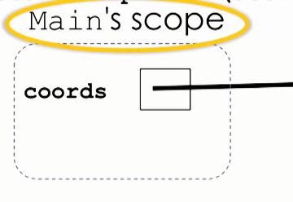

Since coords is object type variable to it will contain the location or reference to the newly created array object



created in heap.

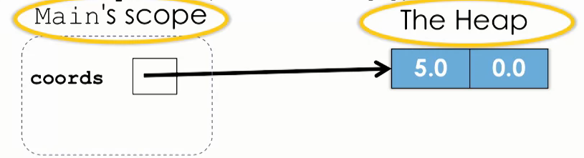

Array Object

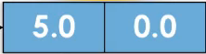

5.0=0th Position of Array Object

0.0=1th Position of Array Object





The type of variable accra is ArrayLocation

The new keyword is constructing a new object



in heap, accra contains the location or reference or location of the newly created object created in heap using new keyword

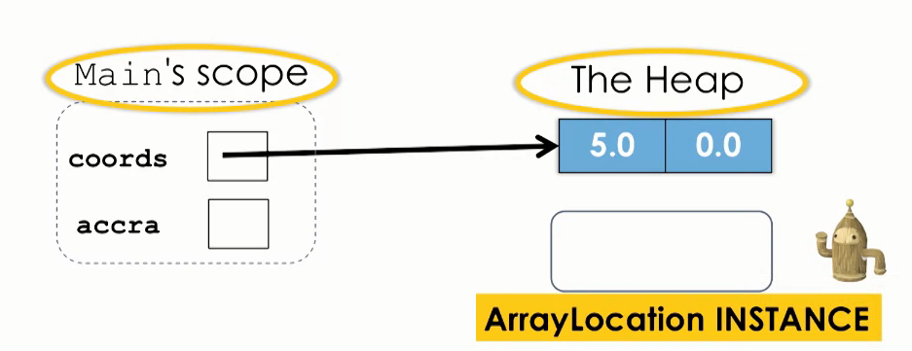

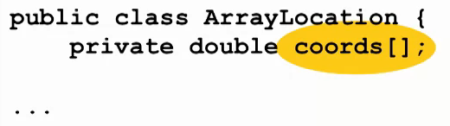

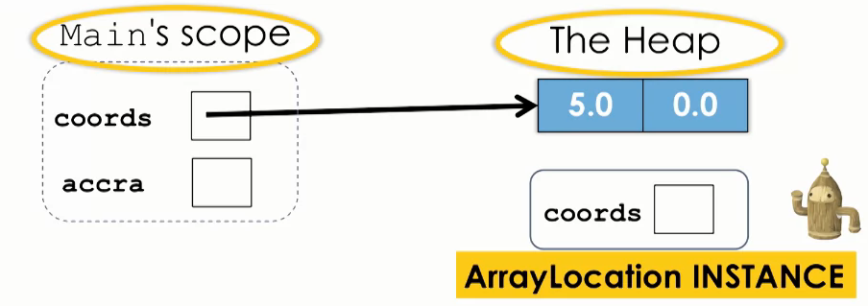



Constructor Scope

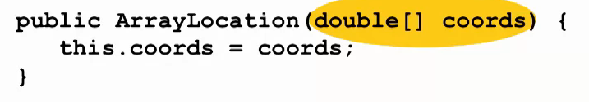



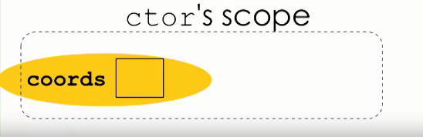

The value of the parameter variable is location or reference or address of the array object

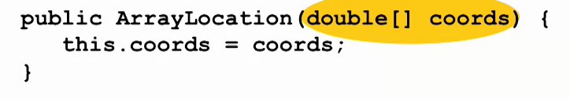



coords parameter variable of constructor points(refers or contains the location or address of the newly created array object) to the variable(array object) we created in heap.







coords has location or address or reference to the newly created object

 in heap(red color)

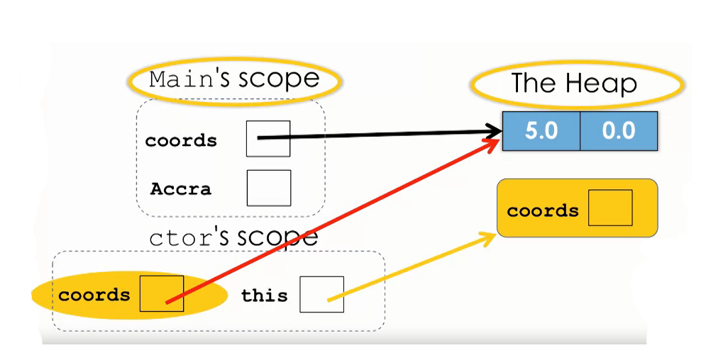

this keyword points(contains location, address or reference) to the newly created

object.



We are setting the value of coords inside object,

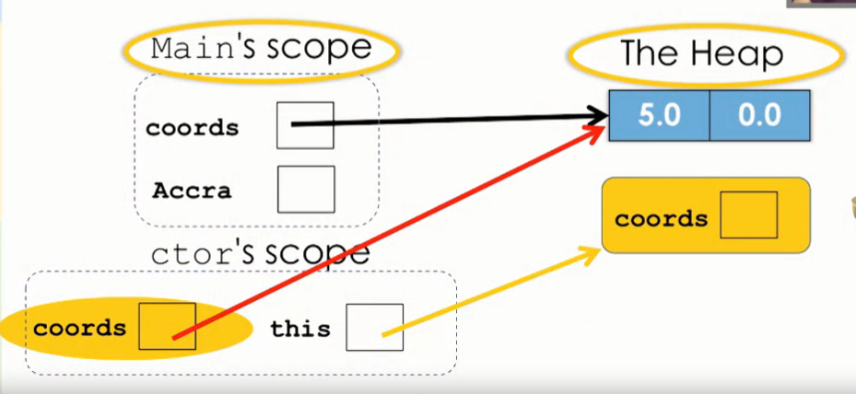



Following is an Object of type

ArrayLocation.

Object Scope of type ArrayLocation





So this.coords will contain the reference or location or address of the object assigned by coords

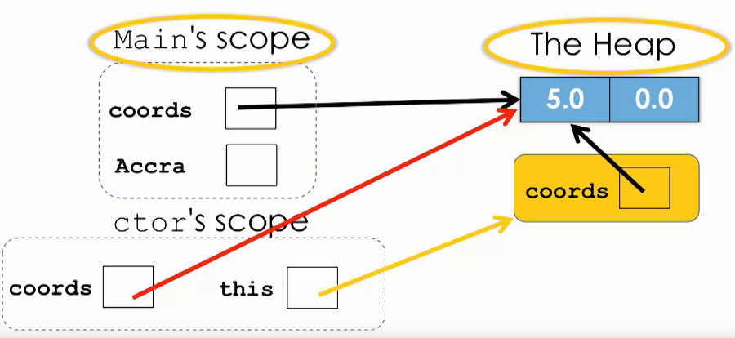

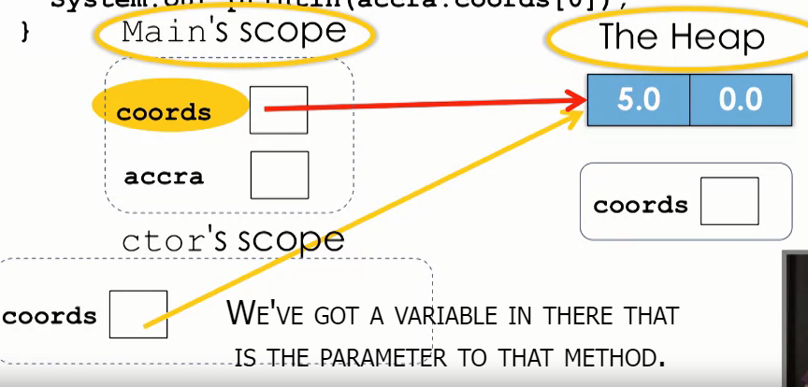



This(variable in constructor scope) key word in constructor point to the location in heap where objects are created.

When we finish with the constructor, we will be returning to main is the reference (location or address) to the object that we initialized.

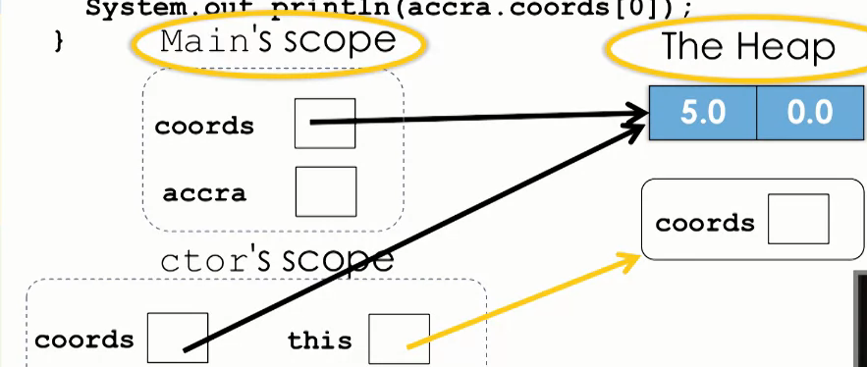



The reference(location or address of object





) that was contained in “this” variable in the constructor gets copied in  variable

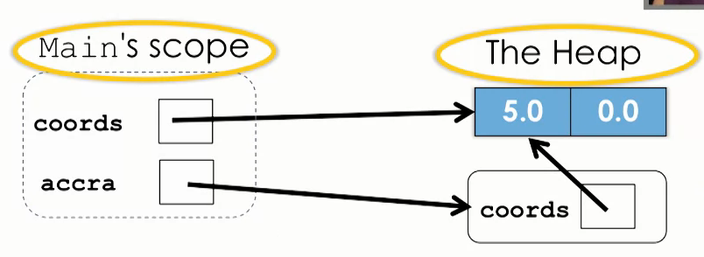





Look at coords in main Scope

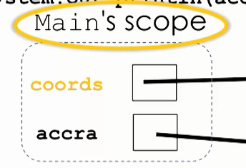 (we are

Setting

 the value of at first position there 32.9)



Go accra, dot means follow the reference from accra to object

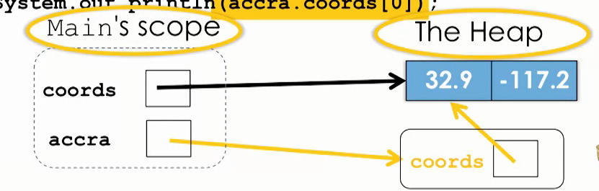

Look for variable (coords) in object scope

coords member variable point to the same array , hence we get output 32.9

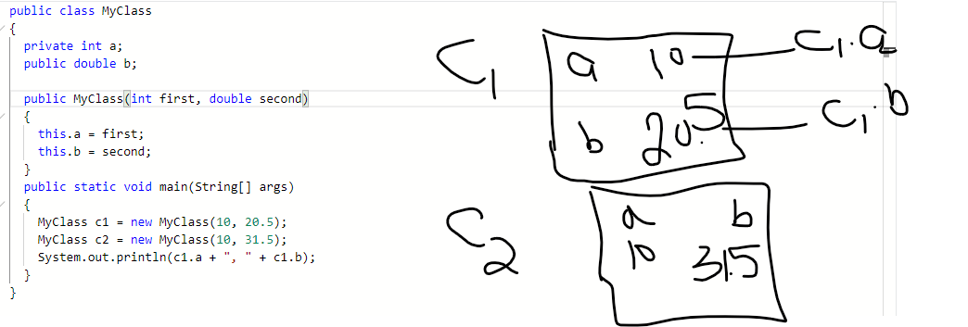



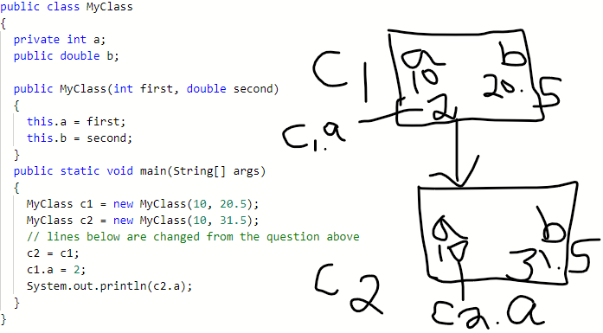



public class MyClass

{

  private int a;

  public double b;

  public MyClass(int first, double second)

  {

    this.a = first;

    this.b = second;

  }

  public static void incrementBoth(MyClass c1) {

    c1.a = c1.a + 1;

    c1.b = c1.b + 1.0;

  }

  // new method

  public static void incrementA(int first)

  {

    first = first + 1;

  }



  // new method

  public static void incrementB(double second)

  {

    second = second + 1.0;



  }



  public static void main(String[] args)

  {

    MyClass c1 = new MyClass(10, 20.5);

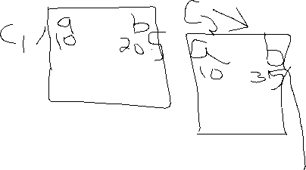

    MyClass c2 = new MyClass(10, 31.5);

    // different code below

    incrementA(c2.a);

    incrementB(c2.b);

    System.out.println(c2.a + ", "+ c2.b);

  }

}

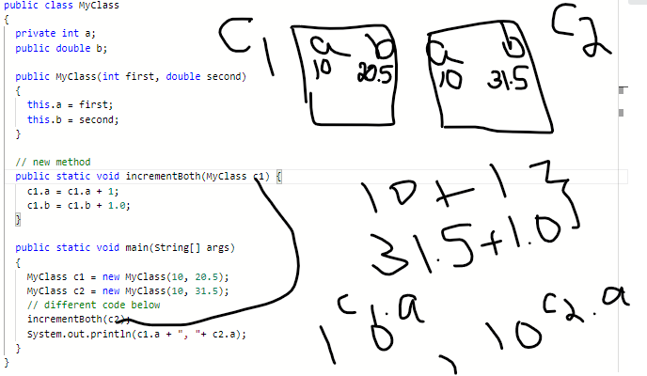

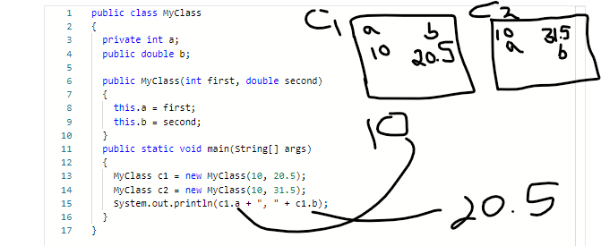



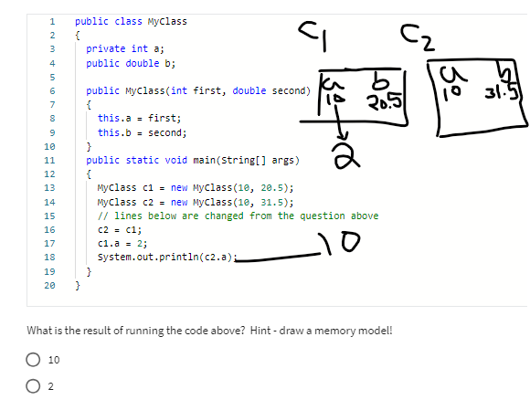



c2=c1 means that c2 will contain the address and location of c1 and hence c2 will point to same object that c1 was pointing.

Hence c1.a=c2.a and c1.b=c2.b

